Read the introduction to Lesson 2-1 in your textbook. Write your answers below

a. What does a value of 3 represent? 3 in. below normal

b. Which city was farthest from its normal rainfall? Salt Lake City, UT

c. How could you represent 5 inches above normal rainfall? +5

Write a definition and give an example of each new vocabulary word or phrase.

|  |  |  |
| --- | --- | --- |
| Vocabulary | Definition | Example |
| 1. negative number |  |  |
| 2. integers |  |  |
| 3. coordinate |  |  |
| 4. inequality |  |  |
| 5. absolute value |  |  |

6. Absolute is a word that is used frequently in the English language.

a. Find the definition of absolute in a dictionary. Write the definition that most closely relates to mathematics. independent of arbitrary standards of measurement

b. Explain how the English definition can help you remember the meaning of absolute value in mathematics. The absolute value of an integer is independent of the sign of the number.

Replace each ● with <, >, or = to make a true sentence.

>

<

>

<

>

=

<

<

>

<

<

<

1. 4 ● −4 2. 8 ● 12 3. −7 ● −5 4. 2 ● 5

5. −1 ● 1 6. 4 ● −3 7. 6 ● 8 8. −2 ● 12

9. 9 ● −1 10. −6 ● −6 11. 5 ● −3 12. −10 ● 2

Evaluate each expression.

21

6

12

4

15

11

6

2

13. |−6| 14. |15| 15. |−12| 16. |21|

17. |4| − |2| 18. |−8| + |−3| 19. |−10| − |−6| 20. |12| + |−4|

Replace each ● with <, >, or = to make a true sentence.

<

<

>

>

>

<

<

<

<

>

>

>

>

=

=

<

1. 1 ● 0 2. –3 ● 0 3. 0 ● −1 4. 0 ● 9

5. −7 ● –7 6. 2 ● −2 7. −2 ● 8 8. −4 ● 4

9. 5 ● 5 10. 0 ● −6 11. 4 ● 10 12. 6 ● −6

13. 3 ● 7 14. −1 ● −2 15. 3 ● 4 16. −3 ● −4

Order the integers in each set from least to greatest.

17. {4, −5, 0} 18. {8, −2, 1} 19. {−6, −3, 0}

{−2, 1, 8}

{−3, −2, 0, 7}

{−10, −8, 1, 15}

{−2, 1, 8}

{−3, −2, 0, 7}

{−10, −8, 1, 15}

{−5, 0, 4}

{−5, −1, 3, 5}

{−4, −1, 3, 12}

20. {−5, 5, 3, −1} 21. {0, −3, 7, −2} 22. {9, −11, 1, 0}

23. {12, −4, 3, −1} 24. {−8, 15, 1, −10} 25. {−12, −17, −20, 2}

Evaluate each expression.

8

4

0

20

10

8

11

9

1

10

15

15

26. 1 27. |−10| 28. |−8|

29. |10| 30. |4| + |−4| 31. |9| − |−5|

32. 0 + |−1| 33. |−6| + |−5| 34. |−8| − |−8|

35. |12| + |−3| 36. |−15| − |6| 37. |−13| + |−7|

Evaluate each expression if a = −3, b = 0, and c = 1.

38. |c| + 2 3 39. 9 − |a| 6 40. |−8| + |a| 11

Replace each ● with <, >, or = to make a true sentence.

1. 0 ● −5 2. 10 ● −10 3. −8 ● 3 4. 11 ● 11

5. −18 ● −18 6. −18 ● 18 7. 18 ● −18 8. 18 ● 18

9. −120 ● −95 10. 35 ● −12 11. −35 ● 12 12. 41 ● 17

Order the integers in each set from least to greatest.

13. {−14, −6, −22, 0} 14. {−3, 19, 0, −5} 15. {−7, 20, −21, 7}

16. {15, −1, 4, −3} 17. {0, −1, 2, −3, 4} 18. {55, 0, −60, 12}

19. {−48, −30, −49, −8, 3, −4} 20. {27, −9, 3, 0, −2, 29}

Evaluate each expression.

21. 22. 23.

24. 25. 26.

27. 28. 29.

Evaluate each expression if a = −3, b = 0, and c = 1.

30. 31. 32.

33. 34. 35.

36. WEATHER At 6:15 a.m. the temperature was −8°F. At 12:15 p.m. the temperature was −12°F. At 6:16 p.m. the temperature was −10°F. Order the temperatures from least to greatest.

1. ELEVATION The surface of the Dead Sea is 1312 feet below sea level. Use an integer to express the surface of the Dead Sea in relation to sea level. −1312

2. FOOTBALL During a football game between the Eagles and the Bears, the quarterback of the Eagles was tackled for a loss of six yards. Use an integer to express the Eagles’ new location on the football field in relation to their previous location. −6

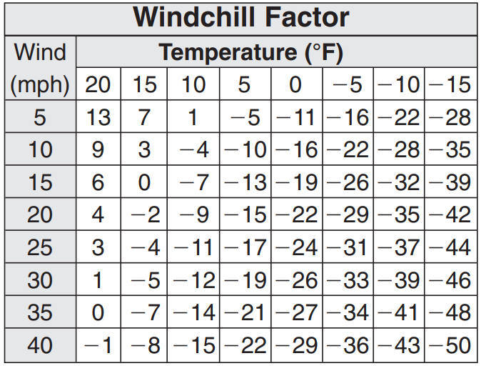

3. WINDCHILL The windchill factor, shown in the table below, indicates how much colder the wind feels than the actual outdoor temperature. How much colder does it feel when the outdoor temperature is 10°F and the wind is blowing at 10 miles per hour? 14°F colder

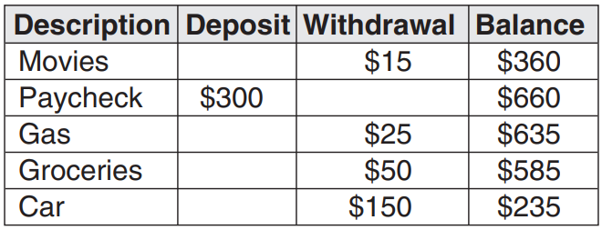4. BANKING One page in Joe’s check register looks like the following table. How do the total deposits compare with the total withdrawals? The value of Joe’s deposits equal $300; the value of his withdrawals equal $240. His deposits are greater than his withdrawals.

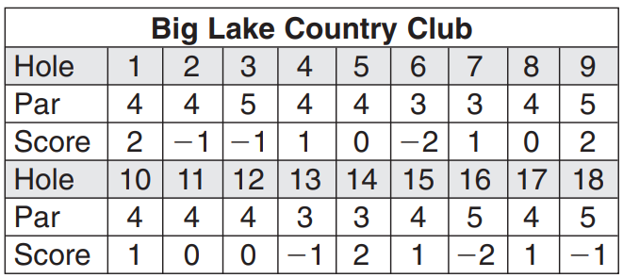GOLF For Exercises 5–7, use the following information. Joe is a golfer. He keeps track of his scores by noting the difference between his score and par, the number of swings it should take the ball to descend into the hole. The scorecard below shows Joe’s scores from a recent round of golf.

5. Compare Joe’s scores on the 7th and 13th holes. 1 > −1

6. Compare Joe’s scores on the 6th and 18th holes. −2 < −1

7. Write the scores for the 1st, 3rd, 4th and 8th holes in the order from least to greatest. −1, 0, 1, 2

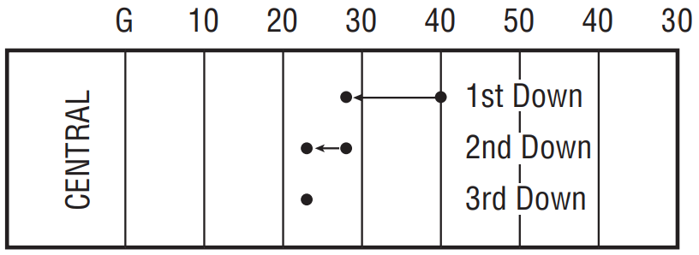

Sam carried the ball from the quarterback 15 times in their game against Southwest High School, and three consecutive times in one series of plays. Sam’s three consecutive carries are illustrated at the right.

1. On 1st down, Sam was tackled 12 yards behind the line of scrimmage. What integer describes the carry? −12

2. On 2nd down, he was tackled 5 yards behind the line of scrimmage. What integer describes the number of yards lost on the play? −5

3. On 3rd down, Sam was tackled on the line of scrimmage. What integer represents the yardage gained on the play? 0

4. Graph the integers from each of the three consecutive carries on the number line below.

5. If you were the coach, would you play Sam in next week’s game against North High School based on the five carries shown in the Examples and Exercises 1–3? Why or why not? No, because he lost yardage on as many plays as he gained yardage

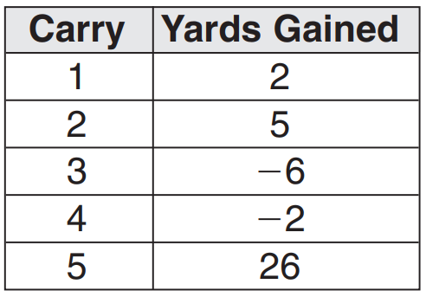

6. The table to the right shows the yards gained or lost each of the first five times that the Southwest High School running back carried the ball. Using this information, write the relationship between the yardage gained or lost on each carry by the Southwest High School running back compared to the Central High School’s running back, Sam.

Carry 1: 2 < 3; Carry 2: 5 > −7; Carry 3: −6 > −12; Carry 4: −2 > −5; Carry 5: 26 > 0